Discover Andaman & Nicobar Islands with INTRO TRAVELS INDIA
The Andaman & Nicobar Islands are one of India’s most breathtaking tropical destinations, famous for crystal-clear waters, white sandy beaches, coral reefs, scuba diving, water sports, lush forests, and peaceful island life. Located in the Bay of Bengal, this tropical paradise is perfect for honeymooners, adventure lovers, families, and beach travelers.
Whether you want luxury beach resorts, thrilling underwater adventures, or relaxing sunsets, the Andaman Islands offer a dream holiday experience.

Why Visit Andaman & Nicobar Islands?
- Crystal-clear turquoise waters
- White sand beaches & tropical beauty
- Best scuba diving destinations in India
- Exotic marine life & coral reefs
- Peaceful island atmosphere
- Romantic honeymoon destination
- Adventure & water sports activities
- Beautiful sunsets & nature views

Top Tourist Attractions in Andaman
1. Port Blair
The capital city and gateway to the Andaman Islands.
Top attractions:
- Cellular Jail
- Corbyn’s Cove Beach
- Marina Park
- Light & Sound Show
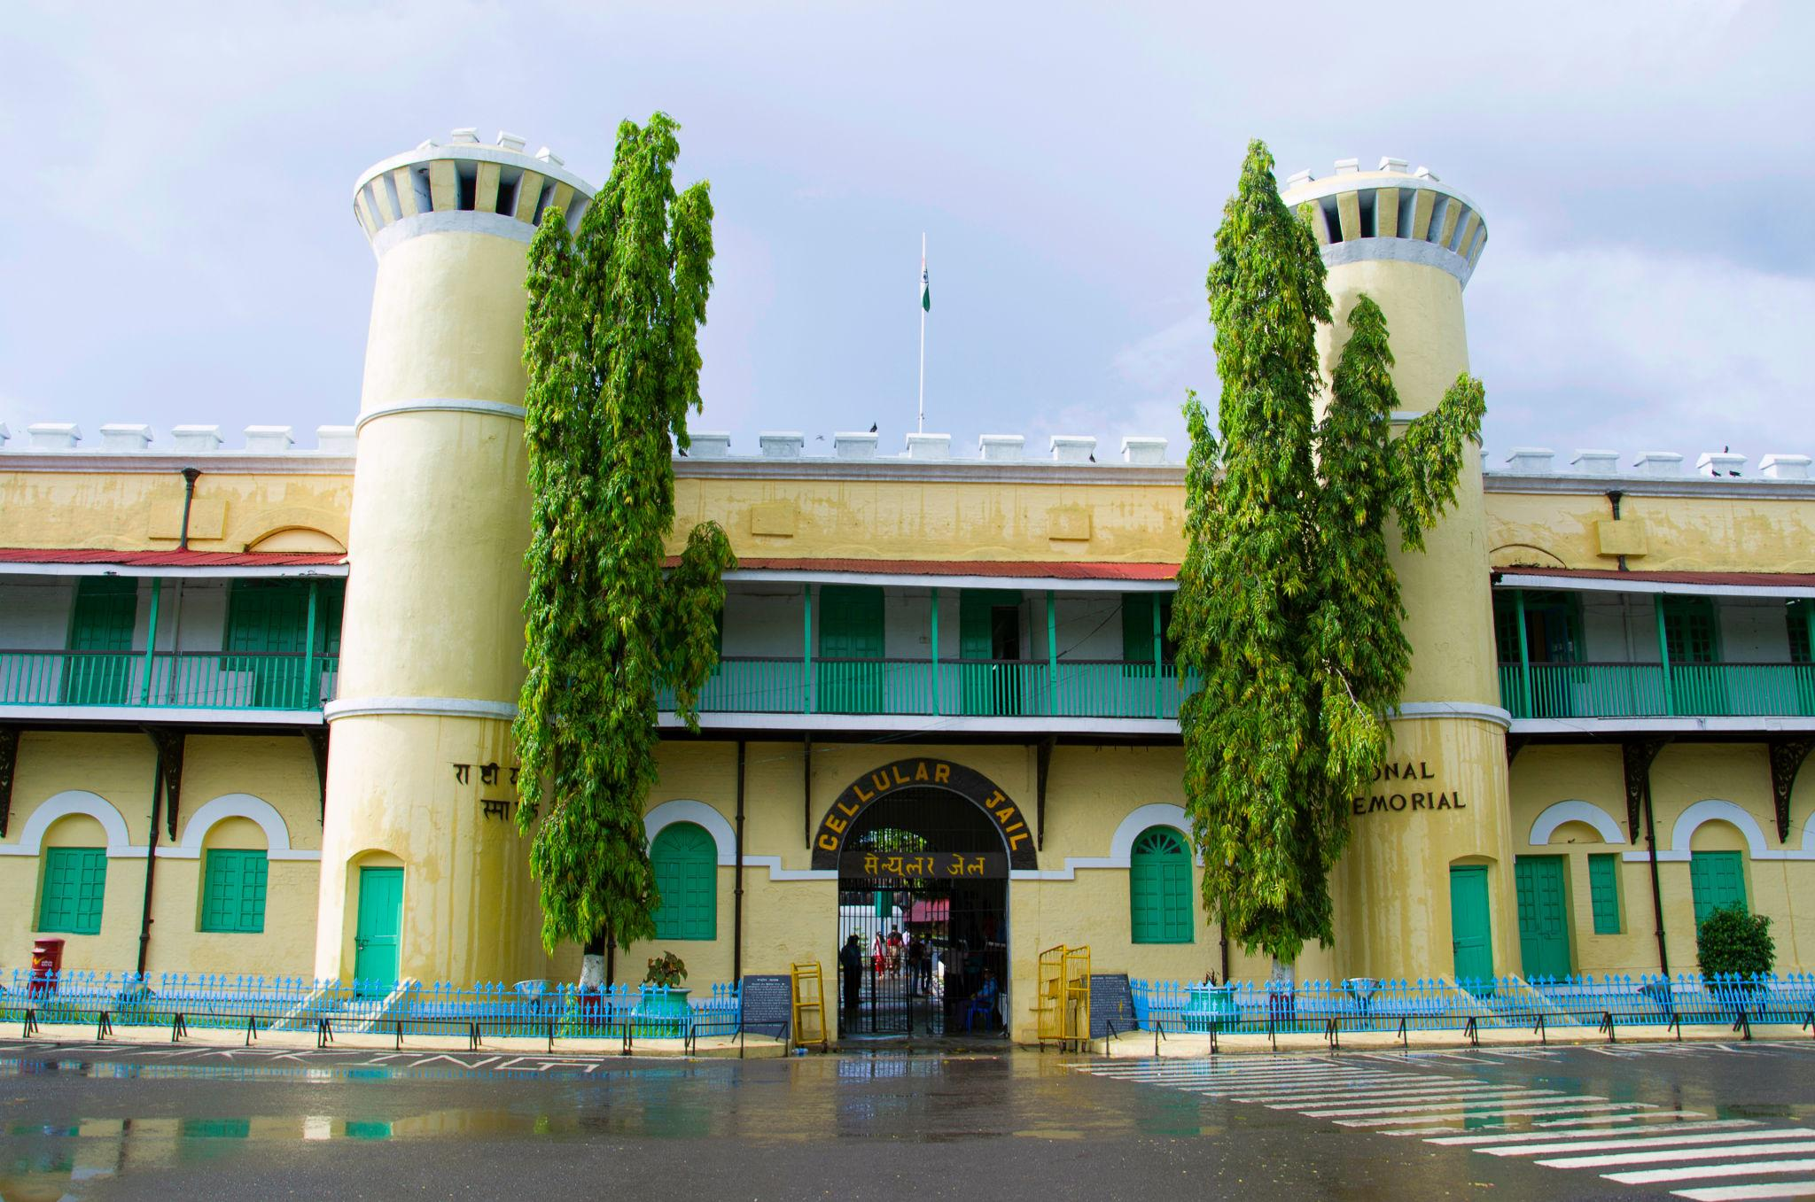
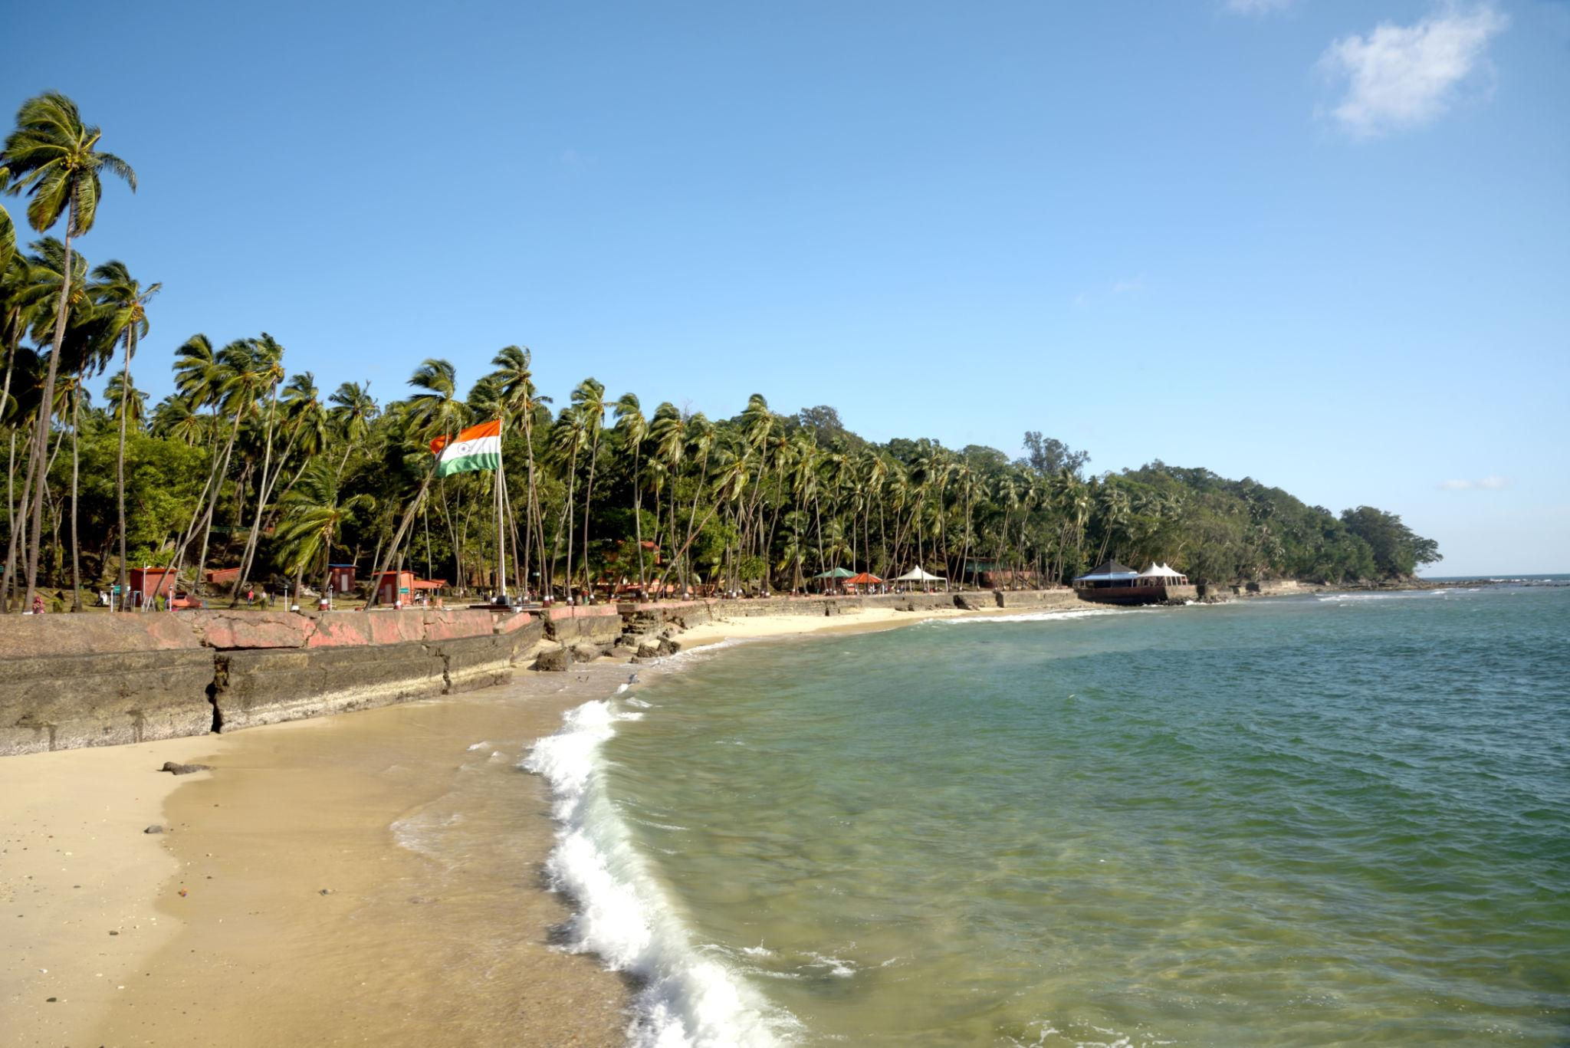
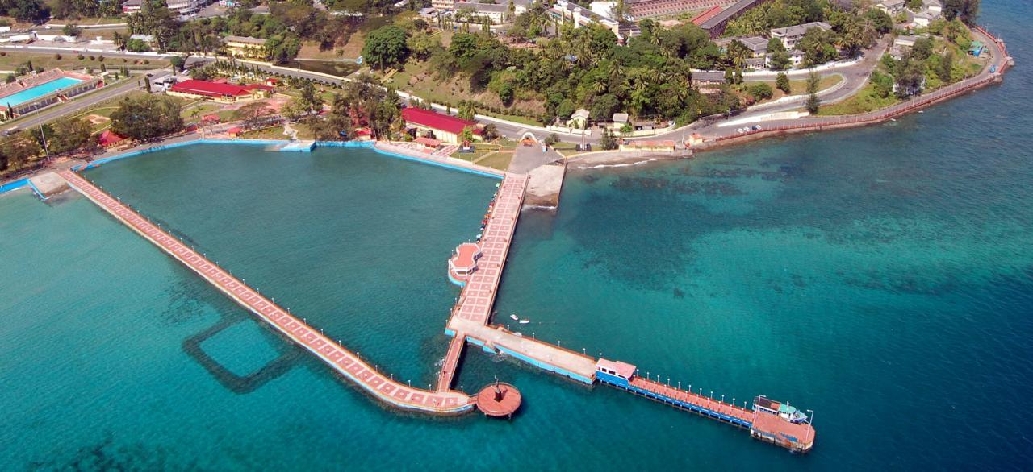




2. Havelock Island
One of the most famous islands in Andaman, known for luxury beaches and diving spots.
Must visit:
- Radhanagar Beach
- Elephant Beach
- Scuba diving spots
- Sunset viewpoints
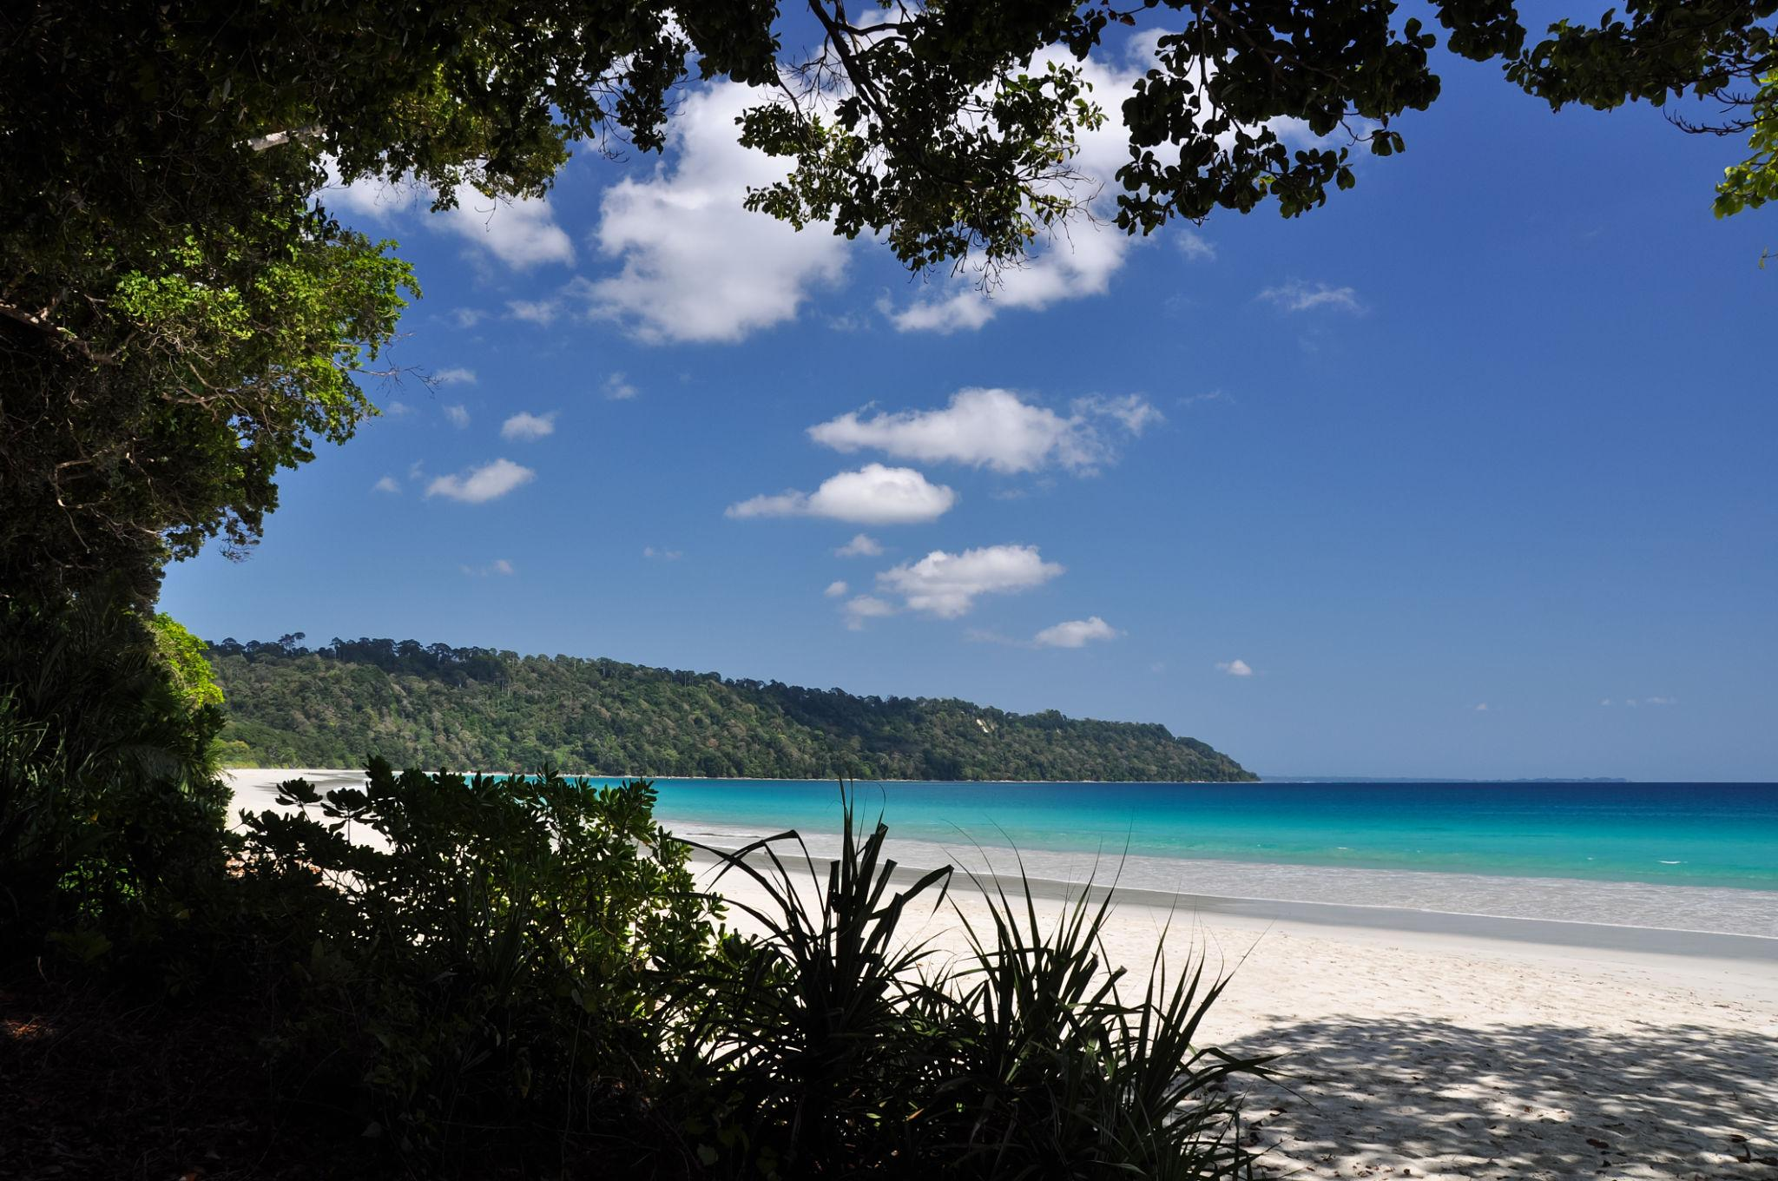
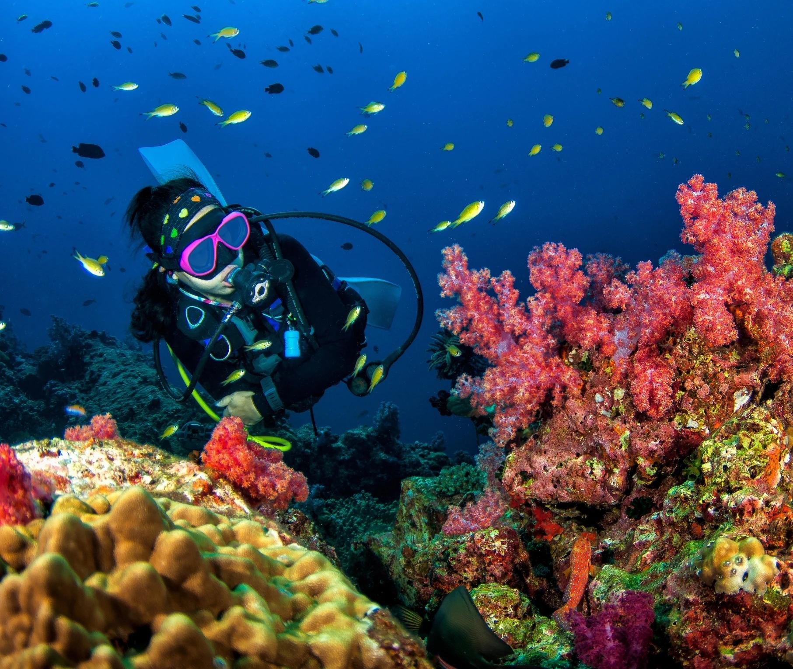
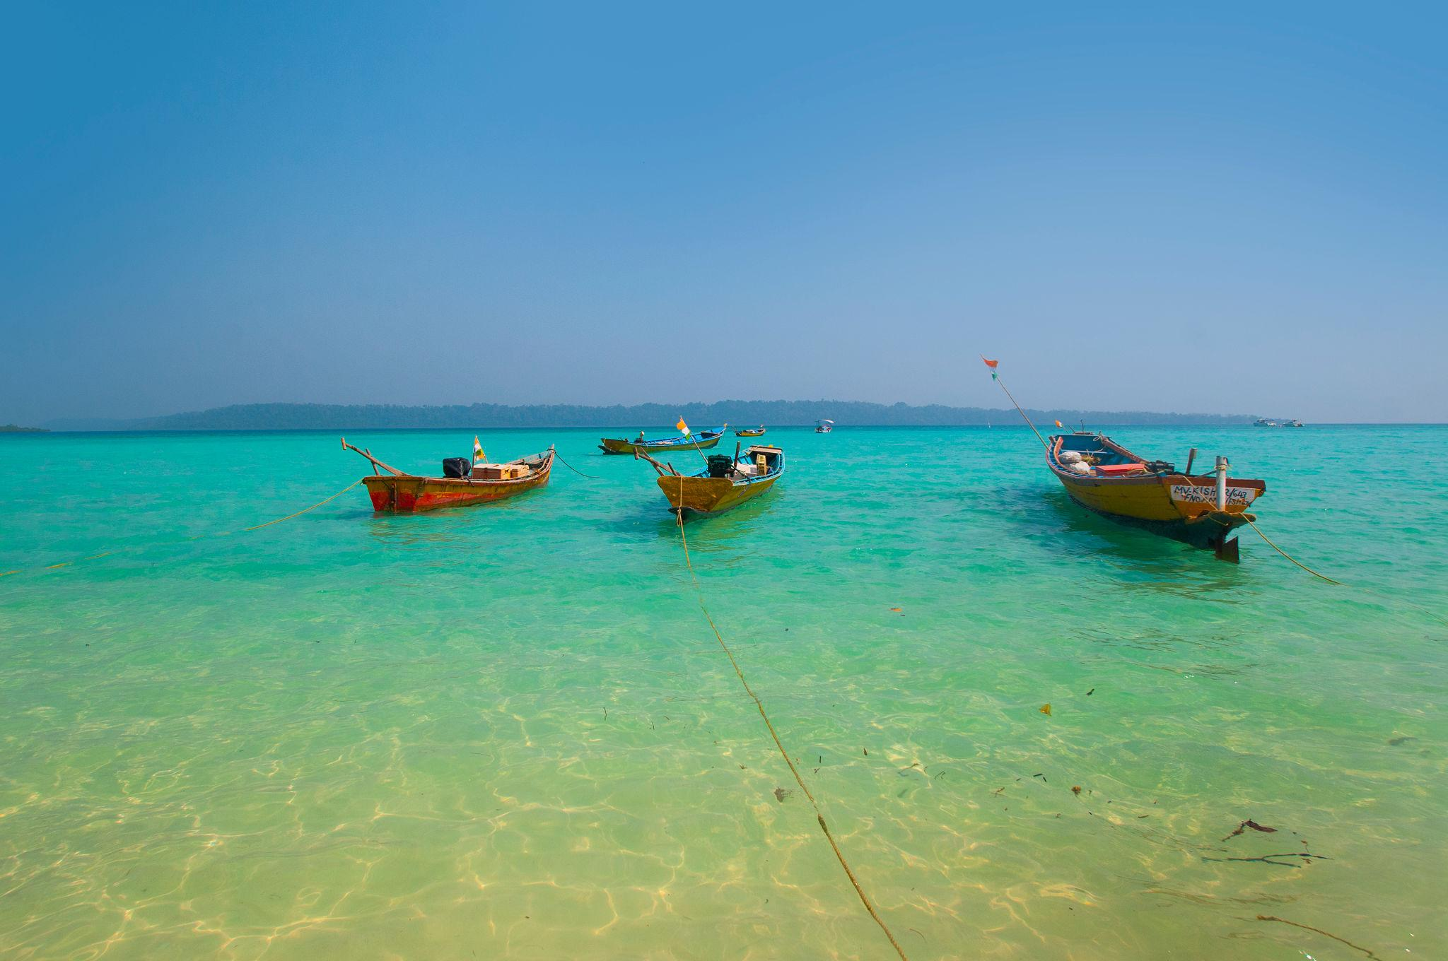
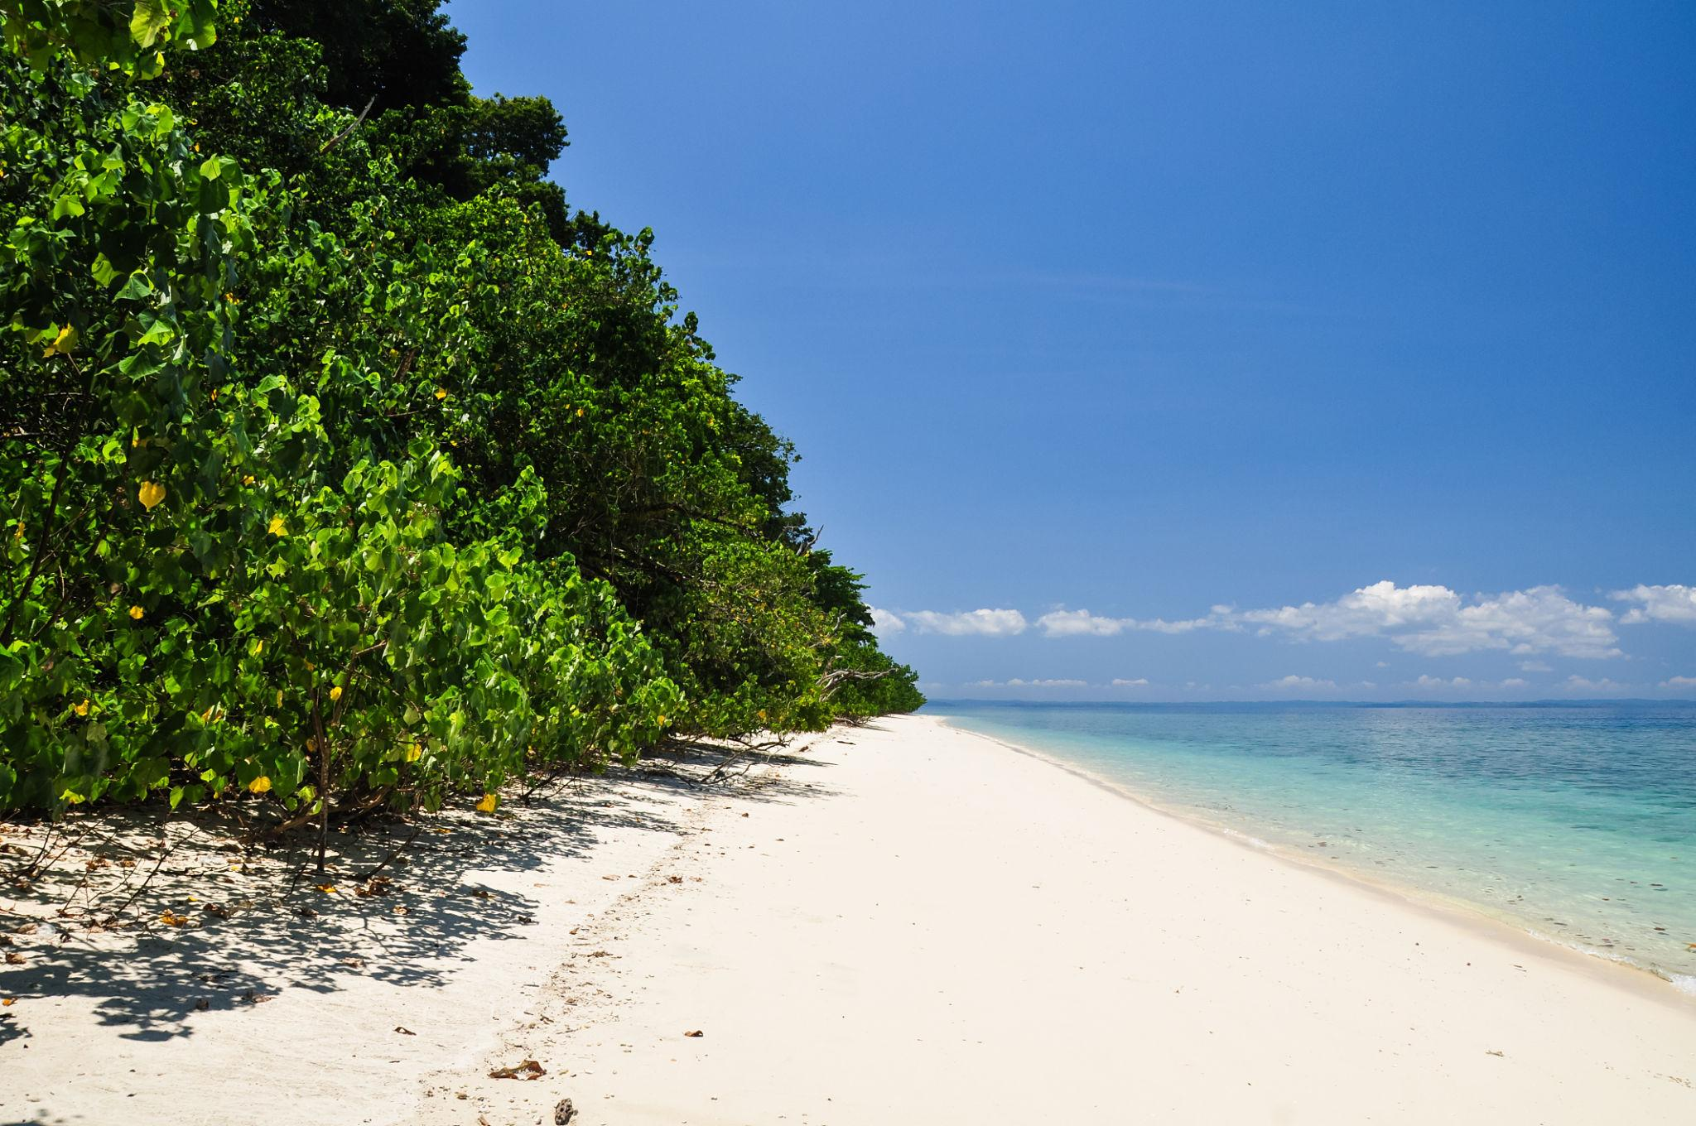
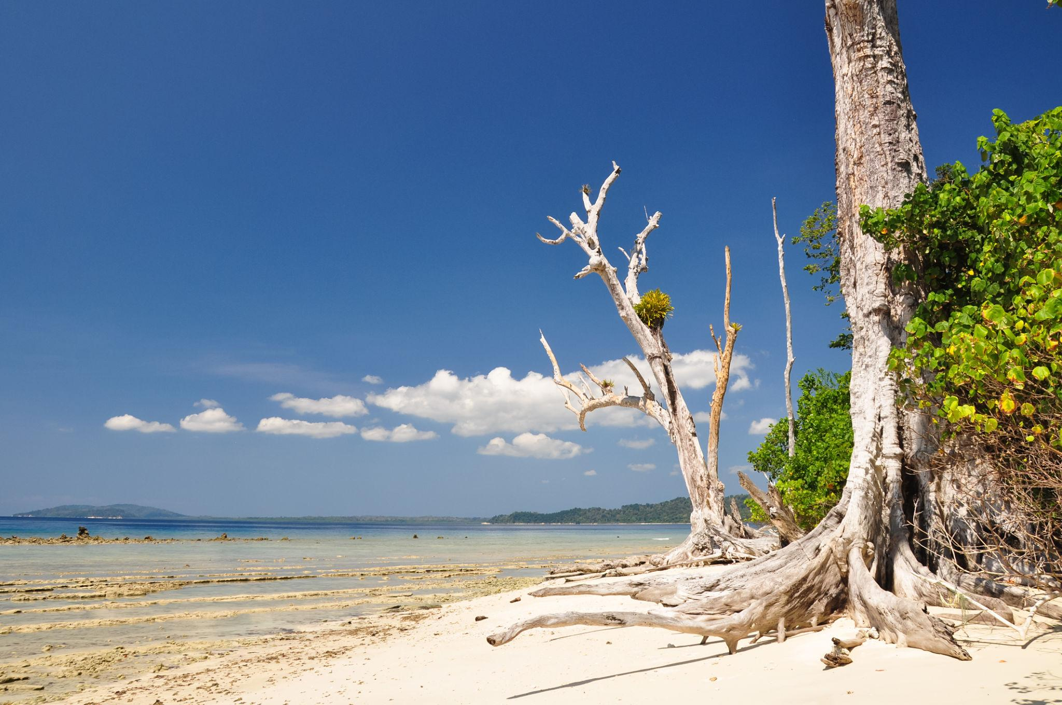

3. Neil Island
A peaceful island perfect for relaxation and nature lovers.
Popular attractions:
- Natural Bridge
- Laxmanpur Beach
- Bharatpur Beach
- Sunset views


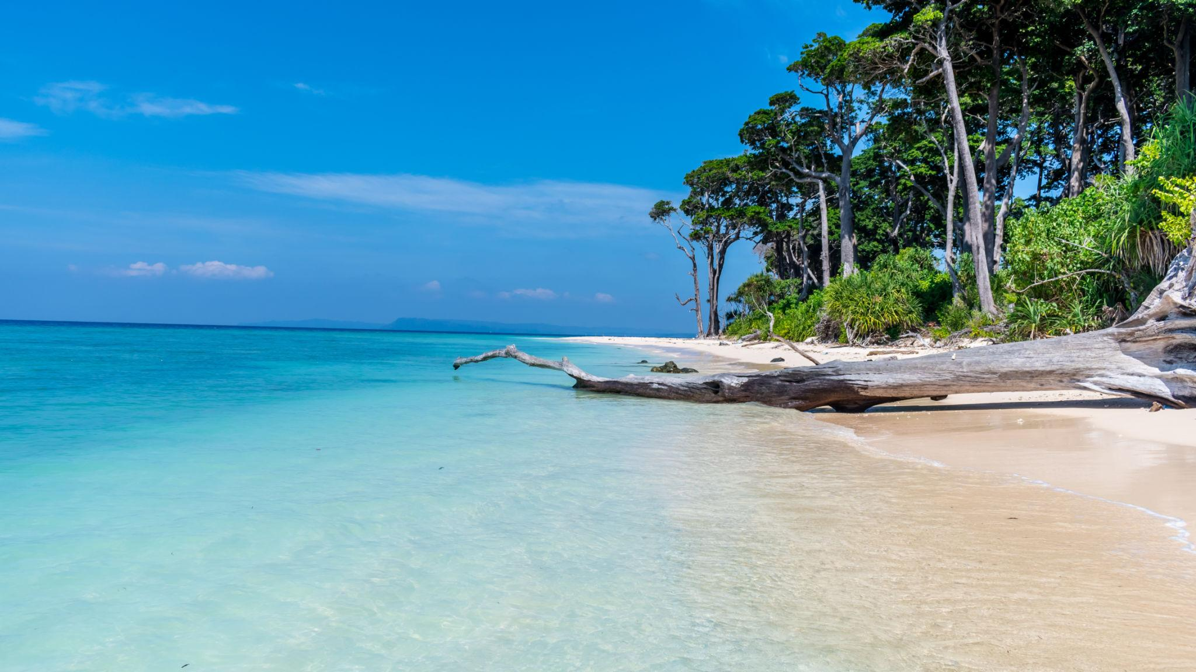
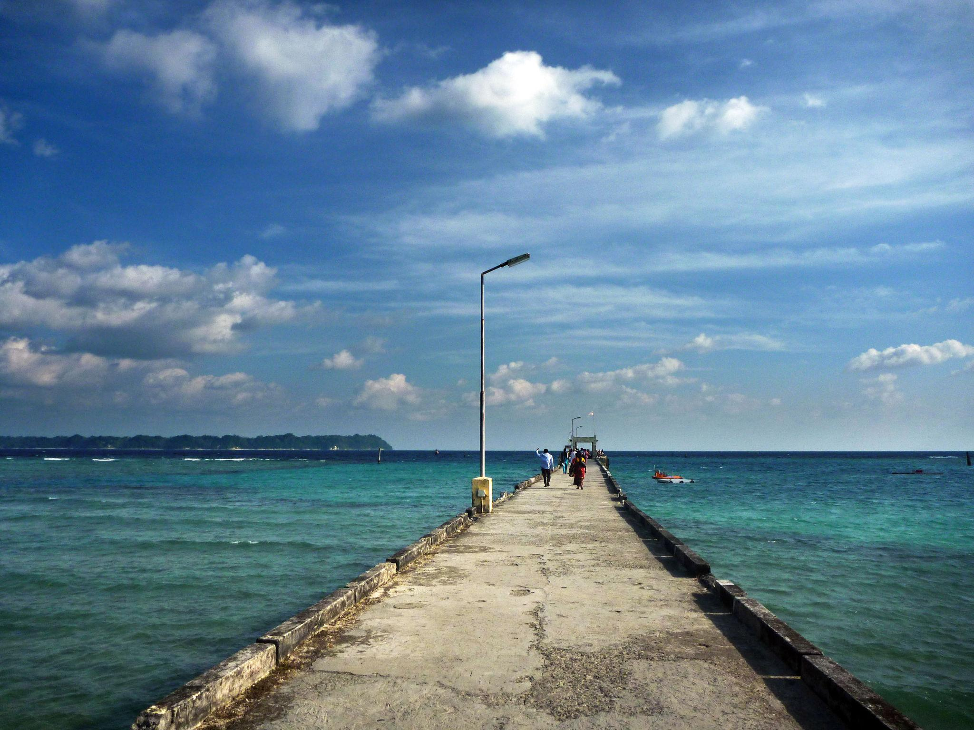

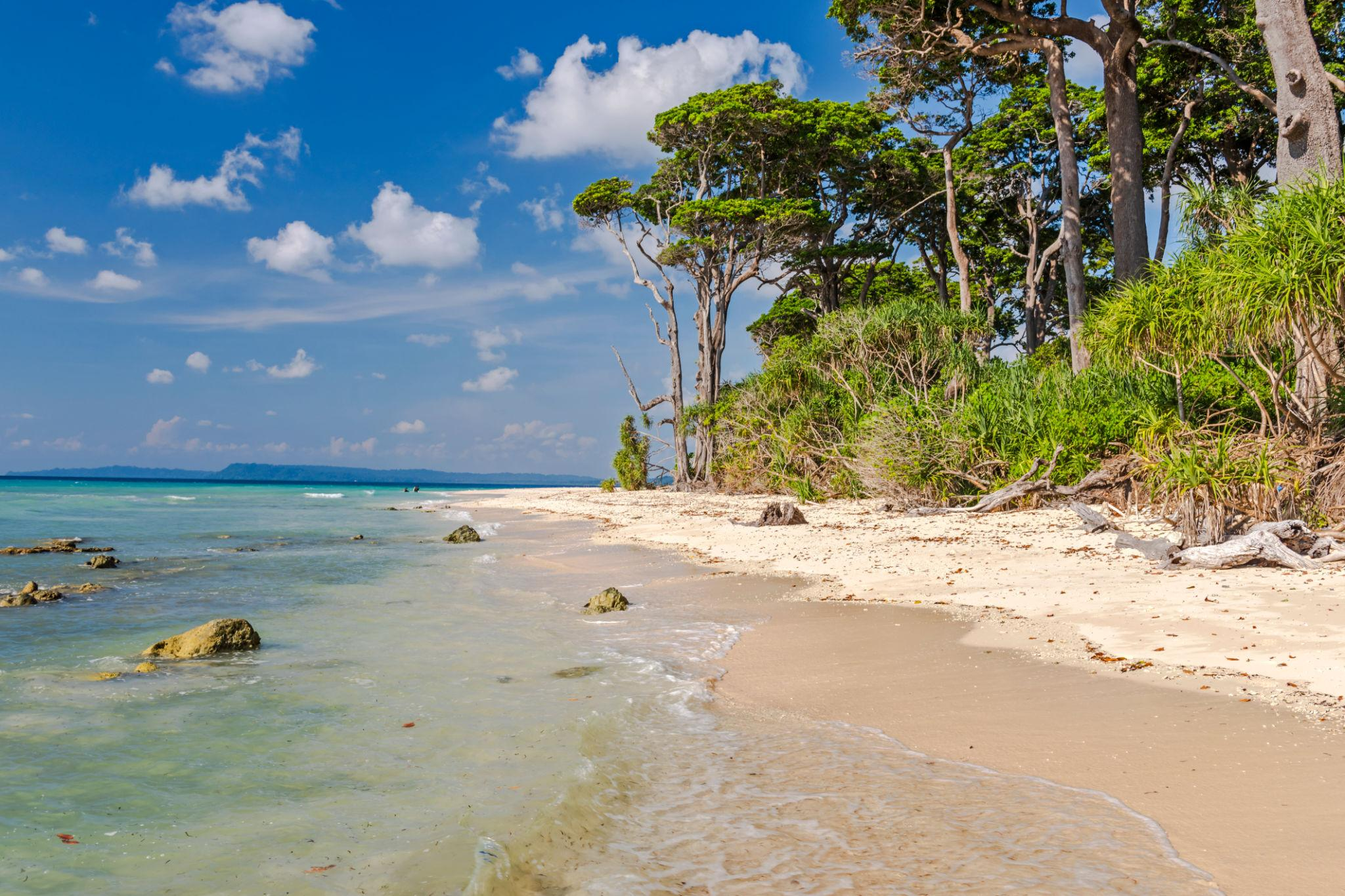
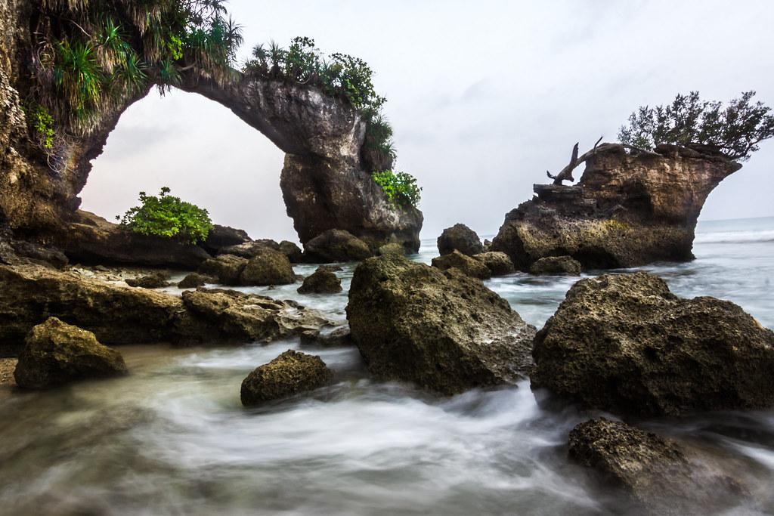

4. Ross Island
A historic island with colonial ruins and scenic beauty.
Known for:
- British-era ruins
- Deer & peacocks
- Ocean views
- Historical significance

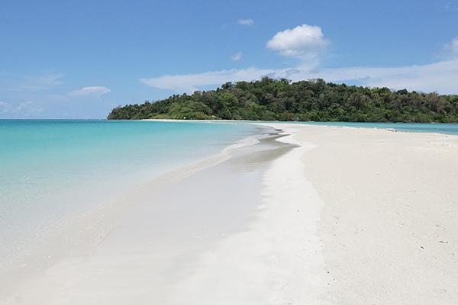

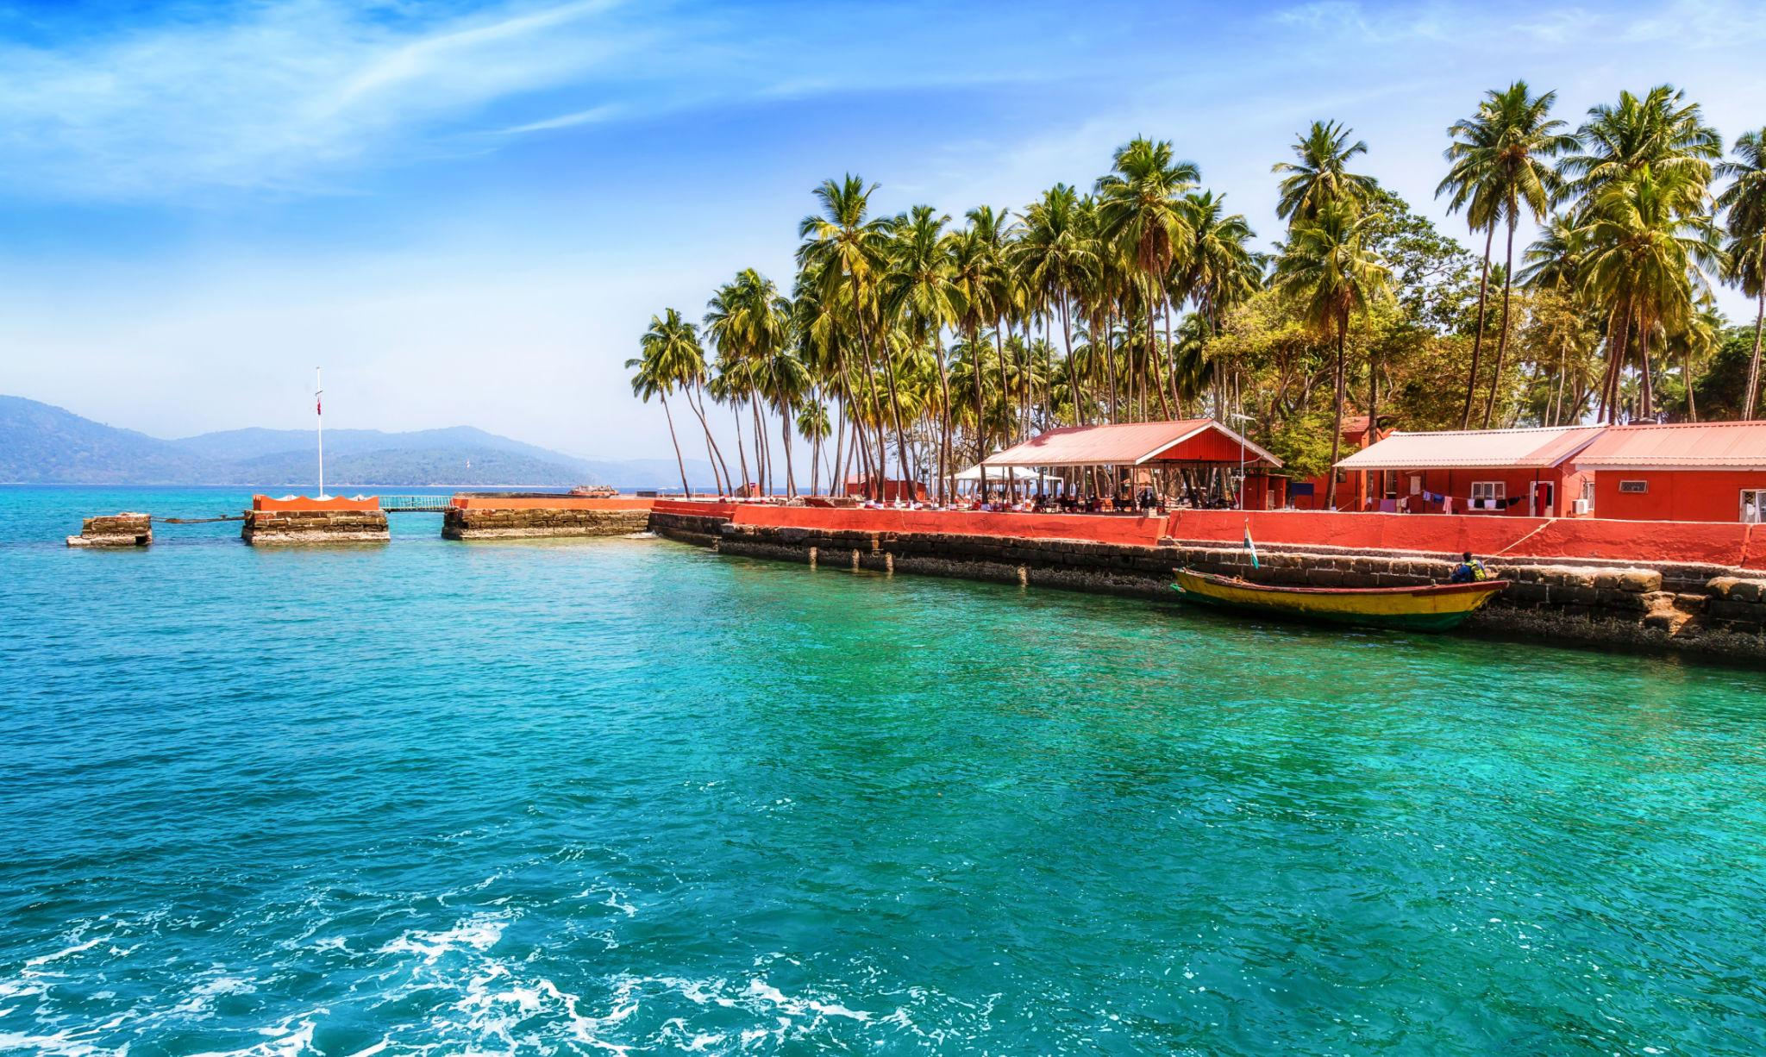





5. North Bay Island
Famous for adventure activities and underwater experiences.
Activities:
- Snorkeling
- Sea walking
- Glass-bottom boat rides
- Scuba diving
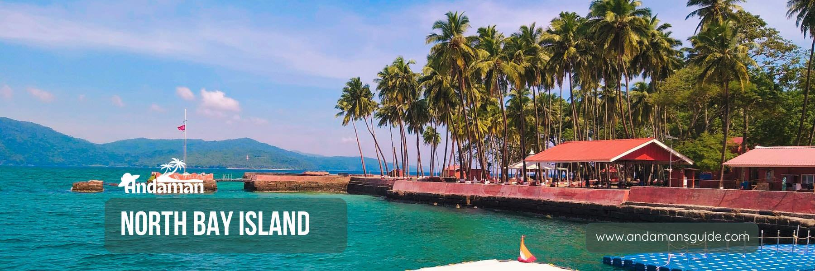


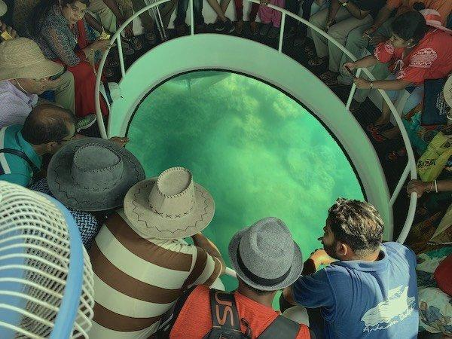

Best Things to Do in Andaman
- Scuba diving & snorkeling
- Sea walking adventures
- Island hopping tours
- Sunset photography
- Relax on tropical beaches
- Explore coral reefs
- Enjoy ferry rides between islands
- Try kayaking & jet skiing
- Watch Light & Sound Show at Cellular Jail

Best Time to Visit Andaman
Season | Months | Weather
Peak Season | October – May | Pleasant & best for water activities
Monsoon | June – September | Heavy rainfall & rough seas
The best time to visit Andaman is from November to April.

How to Reach Andaman
By Air
Nearest airport:
- Veer Savarkar International Airport
By Sea
Passenger ships are available from:
- Chennai
- Kolkata
- Visakhapatnam
Famous Foods to Try in Andaman 🍤
- Fresh seafood
- Grilled fish
- Crab curry
- Coconut-based dishes
- Tropical fruits
- Indian & island cuisine






Luxury Experiences in Andaman ✨
- Beachfront luxury resorts
- Private scuba diving tours
- Romantic candlelight dinners
- Luxury island stays
- Sunset cruises
- Spa & wellness retreats





Andaman Travel Tips
- Carry light cotton clothes
- Keep sunscreen & sunglasses
- Book water sports early
- Carry waterproof bags
- Respect marine ecosystems
- Mobile networks may be limited on some islands

Why Choose INTRO TRAVELS INDIA for Andaman?
With INTRO TRAVELS INDIA, you get:
- Customized Andaman holiday packages
- Honeymoon & family tours
- Luxury beach resort options
- Ferry & flight arrangements
- Water sports bookings
- Guided island tour
- Airport transfers
- Indian meal options
- Group departures & private tours
The Andaman & Nicobar Islands are a paradise where crystal-clear waters, tropical beaches, thrilling adventures, and peaceful island beauty come together for an unforgettable holiday experience.

